CE807 – Assignment 2 – Sentiment Analysis
School of Computer Science and Electronic Engineering – University of Essex
Pranavi Vasa – 1806152
Siddharth Shyamsunder - 1802772

Task – 3
In this task we have summarised the work done as part of task 2. How we have applied machine learning method and calculated the sentiment for the test data.
Importing required libraries:
- We have imported pandas, numpy to do the operations on the entire data easily.
- Imported nltk, from nltk stopword, stemmer to apply them while pre-processing the data.
- Imported train_test_split to split the train data into train and test data to calculate the performance of the model.
- Also imported confusion_matrix,accuracy_score and classification_report to calculate the accuracy of the applied model.
Reading the data:
We have loaded the training and testing data with the help of read_csv file by giving the file name and separation as tab.
Pre-processing the data:
- Stop words removal: We have removed stop words as these occur very frequently in the text data. Example of stop words is a, the.
- Stemming: We have applied stemming to the given data. Stemmer used for this purpose is ‘SnowballStemmer’
We have applied these steps to test data as well.
Concatenating:
We have mixed training as test data to calculate the vocabulary. After concatenating we have fitted the data on tfidf vectorizer. After that we have converted train and test data to numeric format.

Splitting the data:
We have split the train data into 80% train data and 20% test for testing the accuracy of the selected models.

Models:
We have applied MultinomialNB this gave accuracy as below.
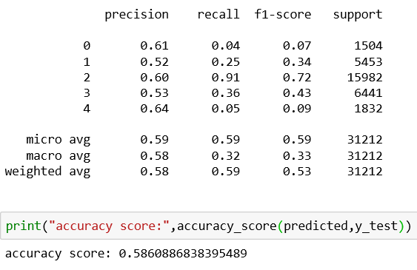

We have applied Perceptron model which gave accuracy as below
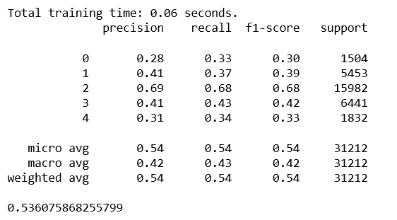

We have applied SGDC classifier which gave accuracy as below
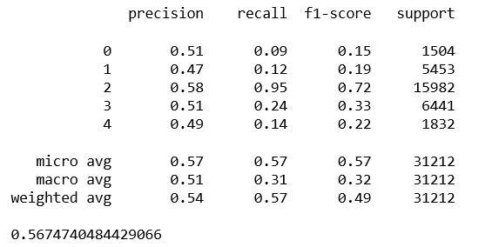

We have applied Deeplearning technique LSTM. We have applied similar steps as above but used token2id for converting text to numerical form.
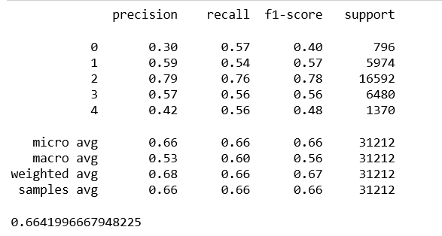
Choosing the model:
We have chosen the model based on accuracy among the 4 models MultinomialNB and LSTM given good results. When we tested on test data by submitting it to Kaggle, got accuracy as 57% for MultinomialNB and 62% for LSTM.
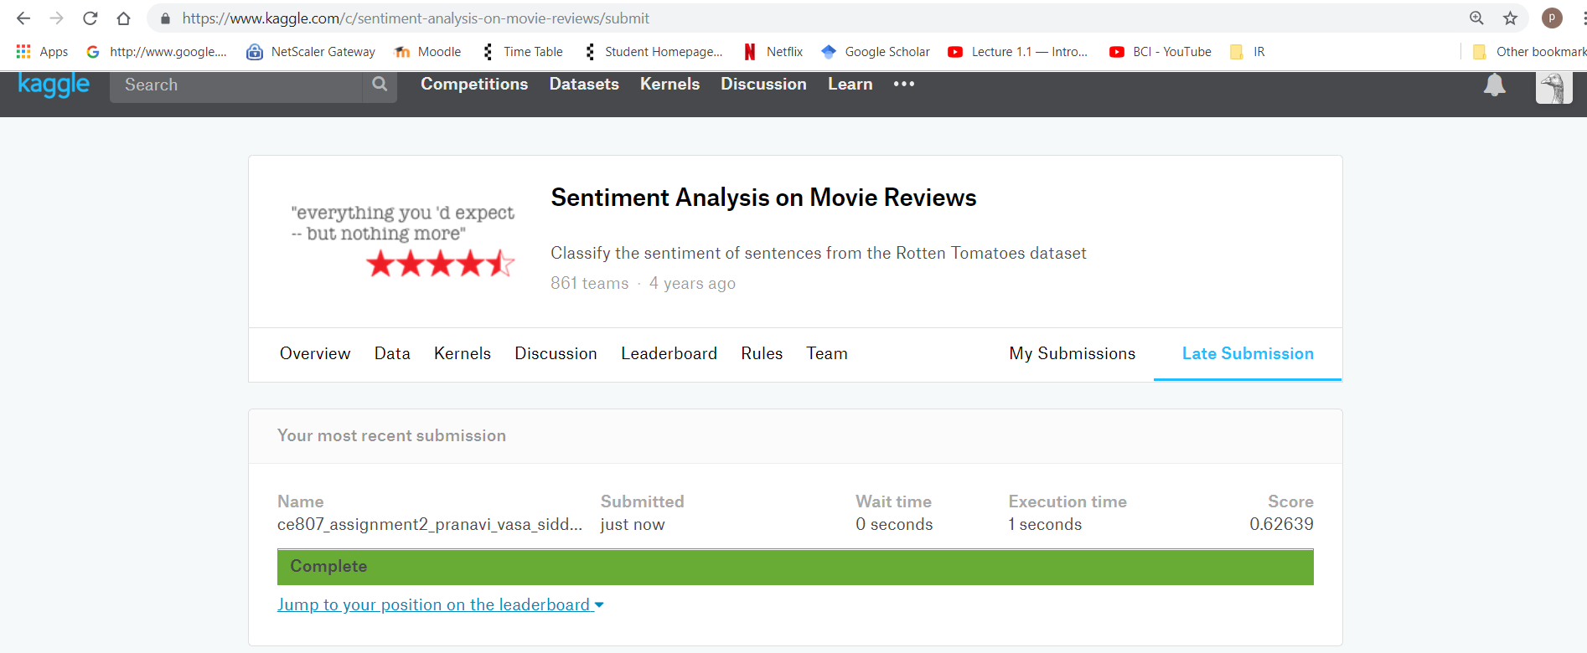
Lessons learnt:
- We have tried to read the data given in tab separated file by opening it after that we have learnt the read_csv function to read the tab separated file.
- We have tried with the presence of the stop words and absence of the stop words. But the absence gave good results. By this we have learnt feature selection to get more accurate results.
- We have tried “one hot encoding” to convert the given text to machine learning model readable format with the help of get_dummies method. But it will take more memory and we are not able to convert the entire data so we have Tfidf vectorizer to do the task to convert the given text to numerical format.
- We have combined train data as well as test data to fit tfidf vectorizer inorder to find the vocabulary for the whole data set.

We have attached below the tried codes for sentiment analysis of the given data.
Final Version of the code:

Initial version of the code:

